1. New Item

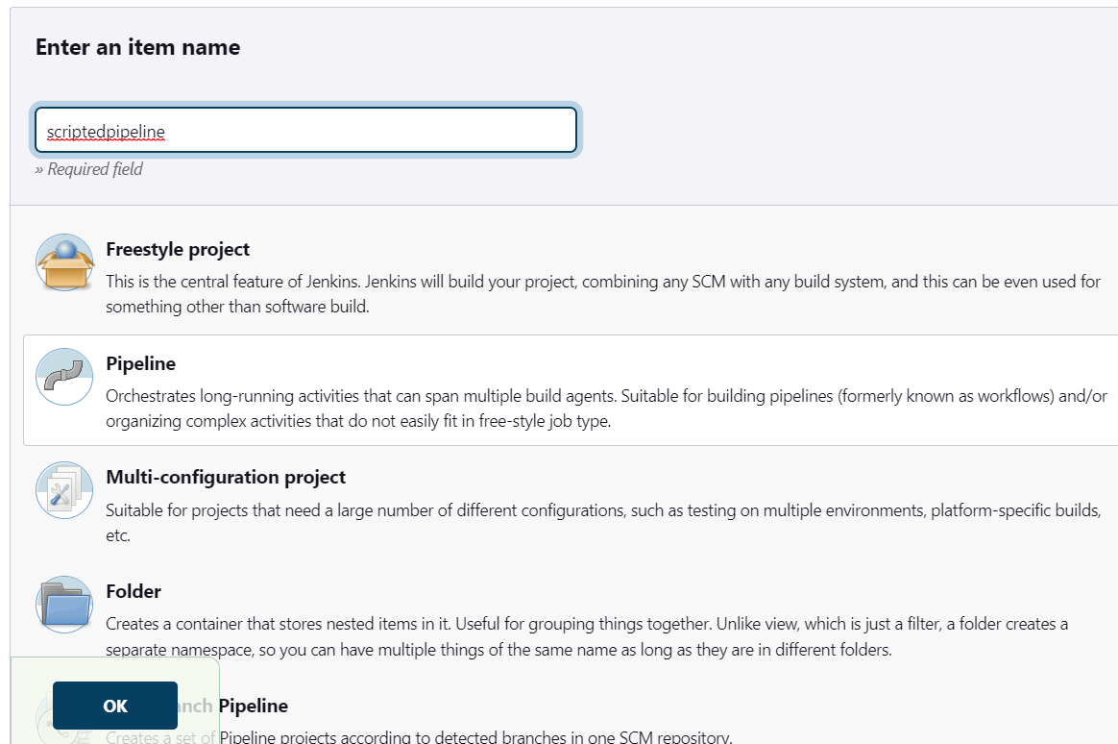

1. Select pipeline and add code

code

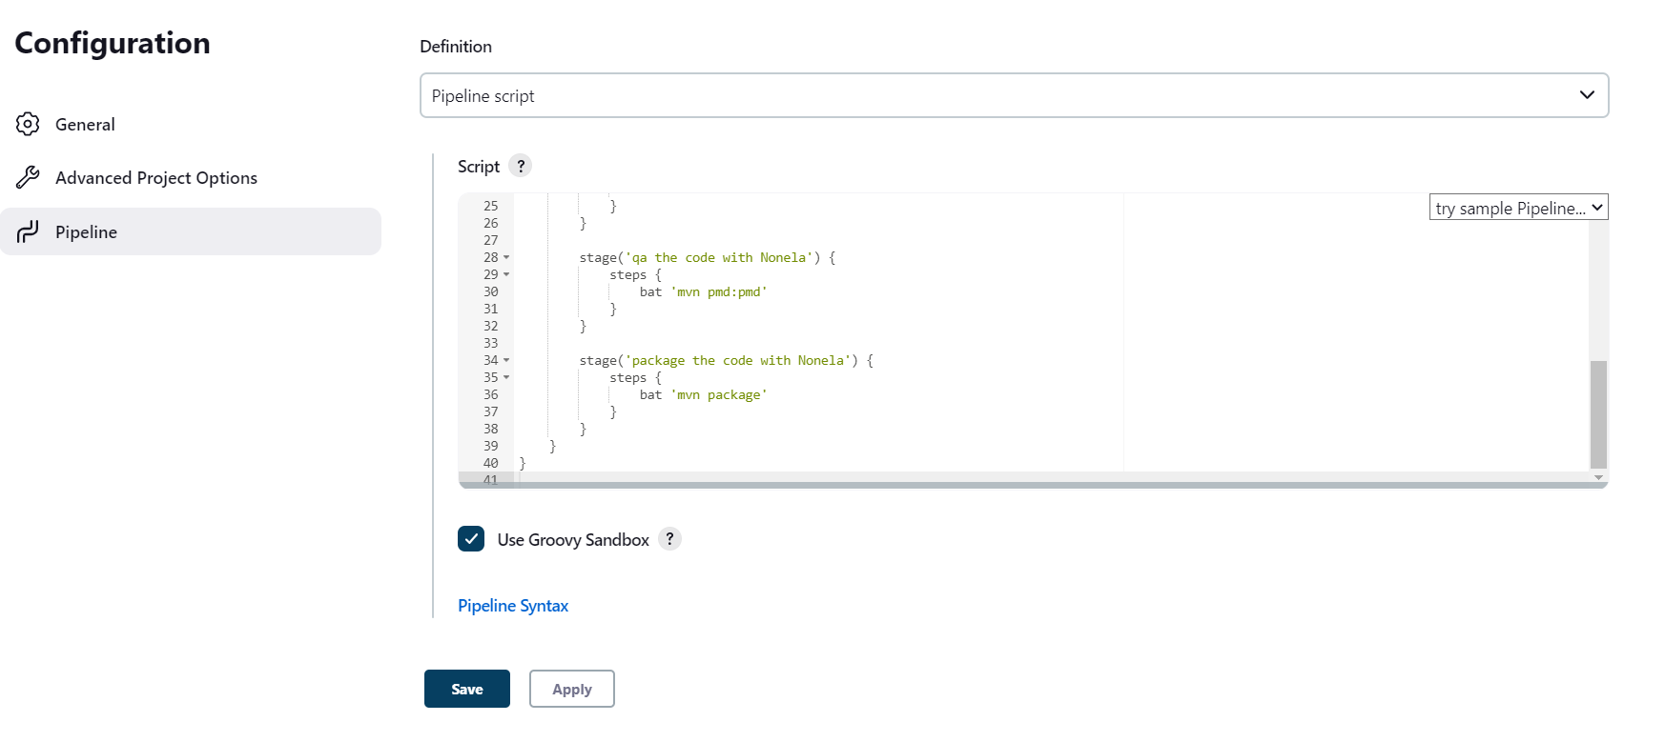

pipeline {

agent any

tools {

// Install the Maven version configured as "M3" and add it to the path.

maven 'mymaven'

}

stages {

stage('checkout') {

steps {

git url: 'https://github.com/NonelaNyongo/DevOpsClassCodes.git'

}

}

stage('Compile the code with Nonela') {

steps {

bat 'sh compile'

}

}

stage('test the code with Nonela') {

steps {

bat 'sh test'

}

}

stage('qa the code with Nonela') {

steps {

bat 'sh pmd:pmd'

}

}

stage('package the code with Nonela') {

steps {

bat 'sh package'

}

}

}

}

